

RESIDENCE APPLICATION
2026-2027

New student applications must be accompanied by a letter indicating why you wish to come to Thorneloe, what you hope to gain from living in residence, and what you can contribute to residence life. It would also be appreciated if you informed us of your hobbies and interests. Please submit applications via email to the Dean of Residence at residence@thorneloe.ca

APPLICATION DEADLINES:
Returning students: March 15th 2026
New Residents: April 15th 2026

2026-2027 RESIDENCE FEE SCHEDULE
RESIDENCE FEES
GENERAL SINGLE ROOM + deposits and fees $8,080
EDUCATION - PRO YEAR + deposits and fees $4,644

PERSONAL INFORMATION

/ /
Laurentian STUDENT NUMBER SURNAME GIVEN NAMES

/ / /
YEAR OF BIRTH GENDER PROGRAM NAME YEAR IN PROGRAM as of Sept. 2026

HOME OR PERMANENT ADDRESS:

/ /
STREET NUMBER & NAME P.O. BOX CITY

/ /
PROVINCE COUNTRY OF CITIZENSHIP POSTAL CODE

/ /
TELEPHONE NUMBER CELL PHONE NUMBER EMAIL

ADDITIONAL INFORMATION:

HEALTH CONCERNS / ALLERGY INFORMATION / ACCESSIBILITY NEEDS

DO YOU CURRENTLY LIVE IN RESIDENCE? NO  IF SO, WHICH ONE? ___________________________

HAVE YOU LIVED IN ANY RESIDENCE BEFORE? NO  IF SO, WHICH ONE? ___________________________

AT ANY TIME WERE YOU ASKED TO LEAVE RESIDENCE YES  NO 

ARE YOU AN EDUCATION STUDENT ENTERING THEIR PRO YEAR? YES  NO 

ROOM PREFERENCE (CANNOT BE GUARANTEED) ____________________________________________________

DID SOMEONE REFER YOU TO THORNELOE UNIVERSITY RESIDENCE? YES  NO 

PLEASE PROVIDE US WITH THEIR NAME: ____________________________________________________________

PARKING:

DO YOU REQUIRE A PARKING PASS? YES  NO 

Parking Fee schedule for the academic year - Please indicate which you require
With plug $564 + $20 Tag Deposit 
Without plug $440 + $20 Tag Deposit 
Education Pro Year $299 + $20 Tag Deposit 

PAYMENT
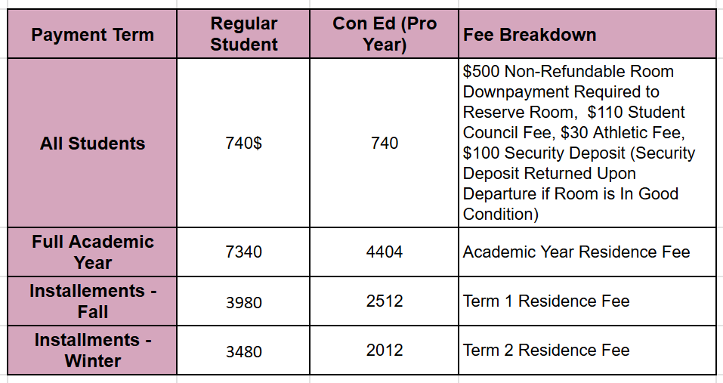
Please select your payment option:
Full Academic Year [September - April] (due by June 30th) 
Installments (Fall due by June 30th, Winter by December 15th) 
*All Non-Refundable Room Down Payments are due by May 15th, 2025 to guarantee your room.

“I CERTIFY THAT THE INFORMATION CONTAINED IN THIS APPLICATION IS ACCURATE”

SIGNATURE DATE

